**Date: May 9, 2024**

**Contact:**  
Roy Kennedy  
916-879-2546  
roy.kennedy@govops.ca.gov

**California Signs Partnerships to Utilize GenAI**

**WHAT YOU NEED TO KNOW**: Leading companies will utilize cutting-edge technology for five specific challenges, working with state teams on how GenAI can enhance customer service, improve health care facility inspections for better care, reduce highway congestion, improve safety for vulnerable roadway users, and improve language access.

SACRAMENTO – California is continuing to implement Governor Gavin Newsom’s [Executive Order on Generative Artificial Intelligence](https://www.gov.ca.gov/wp-content/uploads/2023/09/AI-EO-No.12-_-GGN-Signed.pdf) (GenAI), entering into agreements with five vendors to test, iterate and evaluate GenAI through proofs of concept (POCs). Vendors will utilize GenAI technologies developed by OpenAI, Anthropic, Google, Meta, and others to develop these solutions. The cloud environments used will be Amazon (AWS) Cloud, Google Cloud, Microsoft Azure and ServiceNow (SaaS).

The state will pay each proof-of-concept vendor $1 to test in the “sandbox”, a secure and isolated testing environment. This gives the state and the vendors time to see what works, what doesn’t, and make necessary adjustments during a 6-month window.

“We are now at a point where we can begin understanding if GenAI can provide us with viable solutions while supporting the state workforce,” said Amy Tong, Secretary of the California Government Operations Agency. “Our job is to learn by testing, and we’ll do this by having a human in the loop at every step so that we’re building confidence in this new technology.”

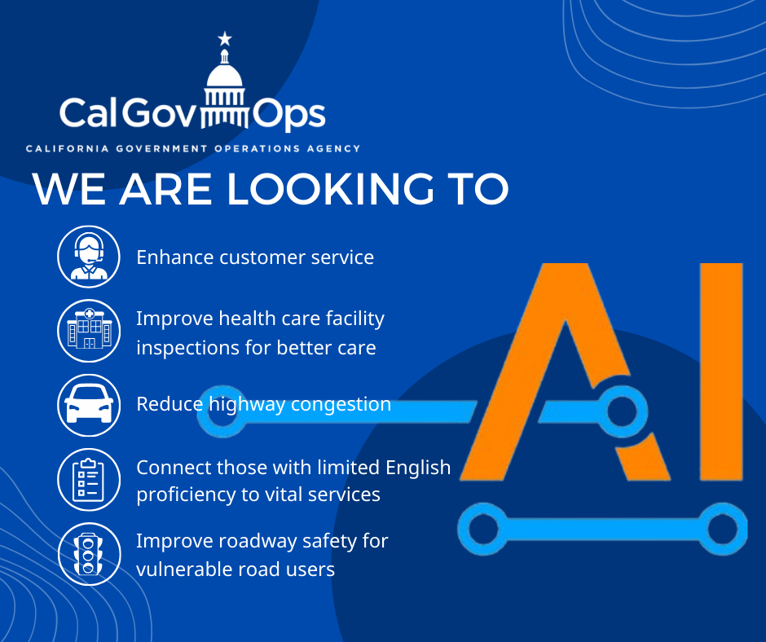

**State partners and selected vendors**

**California Department of Transportation (Caltrans)**

**Vulnerable Road Users**: Caltrans released a problem statement to investigate near misses of injuries/fatalities to identify risky areas and monitor interventions designed to increase safety of vulnerable road users. [Read the full problem statement](https://caleprocure.ca.gov/event/77601/0000029441).

Selected vendors: Deloitte Consulting, LLP and INRIX, Inc.

**Reduce Highway Congestion**: Caltrans released a problem statementto process and interpret complex data to improve traffic pattern analysis, address bottlenecks, and enhance overall traffic management. [Read the full problem statement](https://caleprocure.ca.gov/event/77601/0000029442).

Selected vendors: Accenture, LLP and Deloitte Consulting, LLP

“With an average of 12 Californians dying on our roadways every day, we need to use every tool available to end the roadway crisis and reach our goal of zero traffic fatalities and serious injuries by 2050,” said California Transportation Secretary Toks Omishakin. “Today represents an important step in exploring how GenAI can help save lives. I applaud Governor Newsom and Secretary Tong for being at the forefront of testing how to responsibly harness this cutting-edge technology to help solve some of our most challenging transportation issues and improve the lives of all Californians.”

**California Department of Tax and Fee Administration (CDTFA)**

**Enhance Customer Service**: CDTFA released a problem statement to create new ways to help Californians to understand their business tax requirements by swiftly searching expansive reference materials and providing responses for staff to share with taxpayers via telephone and live chat. [Read the full problem statement](https://caleprocure.ca.gov/event/77601/0000029440).

Selected vendors: Ignyte Group and SymSoft Solutions, LLC

“Generative AI has the potential to enhance services for taxpayers and complement the efforts of our customer service agents,” said CDTFA Director Nick Maduros. “We are always looking for innovative ways to improve service to our taxpayers.”

**California Health and Human Services Agency (CalHHS)**

**Language Access:** CalHHS released a problem statement to assist Californians who are not fluent in English with timely access to information about public benefits and facilitate navigation of public programs. [Read the full problem statement](https://caleprocure.ca.gov/event/77601/0000029672).

Selected vendor: Accenture, LLP

“Our approach at CalHHS is to test these tools in a limited, controlled environment to allow us to choose those that advance a Healthy California for All and scale them appropriately so that historically marginalized communities that use safety-net programs are not only included but first to benefit,” said Dr. Mark Ghaly, Secretary of the California Health and Human Services Agency. “This fast-changing landscape has created new opportunities that, if deployed intentionally, can mobilize the world's information, drive service innovation, increase access, bring services to previously disconnected communities, and enable workers to make smarter decisions, more quickly, and with greater efficiency.”

**California Department of Public Health (CDPH)**

**Improve health care facility inspections**: CDPH released a problem statement to leverage tools to expeditiously document the facts or findings seen by a surveyor during health care facility inspections to develop a concrete set of outcomes or citations that match state and federal requirements. [Read the full problem statement](https://caleprocure.ca.gov/event/77601/0000029673).

Selected vendors: Accenture, LLP and Ignyte Group

“CDPH is constantly striving to find new and innovative ways to ensure Californians continue to have access to safe, high-quality care,” said Dr. Tomás Aragón, CDPH Director and State Public Health Officer. “GenAI helps propel us forward in these efforts by streamlining our oversight processes, making them more efficient and consistent for our highly-qualified surveyors and more beneficial for health facilities and the communities they serve.”  
  
**Why it’s important**  
  
The next phase of the GenAI POCs will now move into a secure “sandbox”, a secure and isolated testing environment held by the California Department of Technology (CDT).

Working side-by-side with state teams, each vendor will test their proposed GenAI solutions using real, publicly available data to create a realistic representation of state operations. CDT will be collaborating closely with their state partners and the vendors to assess the accuracy, security, and privacy of their solutions to refine any necessary technology requirements during this process.

At the conclusion of this process, the Office of Data and Innovation (ODI) will help assess future agreements. ODI will ensure a human-centered design approach, combined with research-backed insights and high-level evaluation metrics to help inform the state’s prospective GenAI solutions.

**What our vendors are saying**  
"The responsible introduction of generative AI into state practices is of the utmost importance for California, and we and Microsoft are honored to partner with the State on this priority,” said Mark Noriega, Accenture’s managing director for the State of California. “Gen AI will accelerate innovation, reshaping perceptions of what's possible.”

“Deloitte is proud to collaborate with California leaders and Google to develop and deploy trustworthy technologies that can help enhance traffic safety, improve the efficiency of transportation systems, and upgrade the travel experience for millions of Californians,” said Rachel Frey, principal, Deloitte Consulting LLP.

"Ignyte is ecstatic that the State of California has chosen two of our innovative solutions (powered by ServiceNow’s Now Assist AI) for the practical application of Generative AI in the public sector,” said Jason Stanis, Chief Technical Officer, Ignyte Group. “As a consulting firm focused 100% on digital transformation, our DNA is all about practical innovation. We are not interested in hype or buzzwords. We solve real-world problems for our clients with automation and AI.”

“Leveraging 20 years of insights, our massive data lake, and our new GenAI technology, we are honored to collaborate with Caltrans to improve safety for vulnerable road users (VRU)," said Bryan Mistele, CEO at INRIX. " Together with Caltrans, we will leverage the unique power of generative AI to uncover underlying causes, and prescriptive solutions to pave the way for a safer transportation future."

“SymSoft is enthusiastic about the potential of Generative AI to elevate Customer Service and Customer Engagement,” said Savita Farooqui, Director of Research, SymSoft Solutions. Our approach not only enhances operational efficiency but also enriches the customer experience. By implementing robust AI governance and effective safeguards, we are dedicated to delivering AI solutions that genuinely benefit our customers.”

For more information about the GenAI work happening in California, please visit the state’s [GenAI website](https://cdt.ca.gov/technology-innovation/artificial-intelligence-community/genai-executive-order/). The site includes Governor Newsom’s Executive Order, announcements and other milestone information.