

**FOR IMMEDIATE RELEASE:** Monday, September 30, 2024

**Contact:**  
Angela Musallam  
916-216-3766  
[angela.musallam@govops.ca.gov](mailto:angela.musallam@govops.ca.gov)

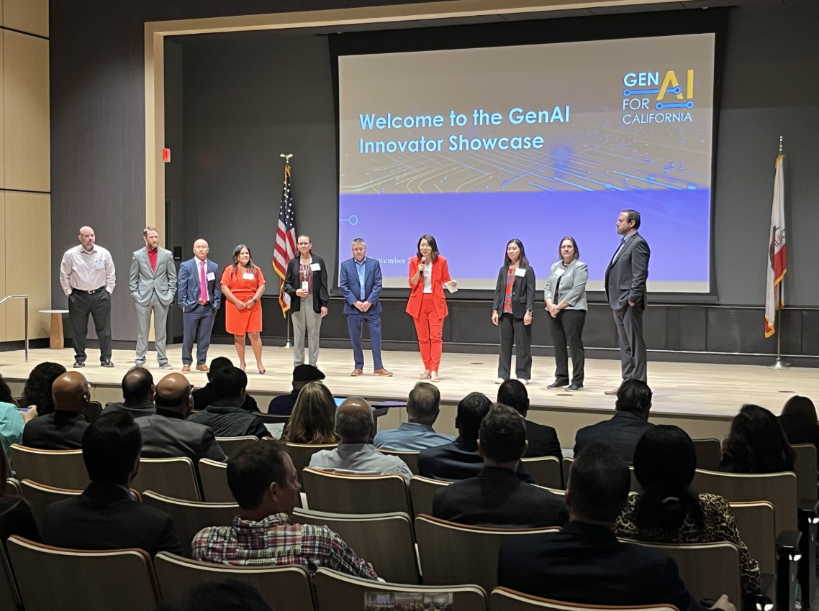

# **California Hosts its First Ever GenAI Innovator Showcase in Sacramento as State Departments Seek Answers to Top Issues**

**SACRAMENTO –** More than 30 tech innovators from across California gathered in Sacramento Thursday to discuss how cutting edge generative artificial intelligence (GenAI) technology can help solve critical state issues from homelessness to better forecasting the impacts of a recession.

California’s Government Operations Agency hosted this first large-scale showcase as an opportunity to conduct market research and explore emerging GenAI technology to enable state departments to better serve the residents of California.

Leaders from the Department of Finance; Labor, Workforce & Development Agency; California Health and Human Services Agency; Business, Consumer Services and Housing Agency; Employment Development Department; and Housing and Community Development Department heard more than 60 presentations, collectively, and engaged directly with tech innovators on specific [challenges](https://caleprocure.ca.gov/event/77601/0000032633) facing their departments.

“The robust interest we received from innovators in this showcase is a testament to important work being done by California to integrate GenAI into the state sector, considering California remains the tech capitol of the world,” **said GovOps Secretary Tong**. “The goal is to use this technology to enhance our services, not replace our workforce.”

“Today’s AI showcase was an incredible opportunity to hear and see the possibilities of incorporating GenAI into our operations. My team and I are excited to further explore GenAI to enhance and complement our existing operations,” **said Joe Stephenshaw, Director of California’s Department of Finance**.

As part of Governor Newsom’s GenAI [executive order](https://mclist.us7.list-manage.com/track/click?u=afffa58af0d1d42fee9a20e55&id=3a33cf1d61&e=4445b5a765), the Governor convened a [summit on GenAI](https://mclist.us7.list-manage.com/track/click?u=afffa58af0d1d42fee9a20e55&id=882bb71a88&e=4445b5a765) earlier this year with leaders from across industries – including technology, labor, government, and academia – to discuss how the state can best use this transformative technology to better serve the people of California.

State agencies and departments began analyzing potential uses for GenAI and identified critical challenges within state government that could benefit from it. Technology discussed at the showcase addressed those challenges. This is not a formal procurement process but market research that is often used by the state to identify what is currently in the marketplace. Potential procurements are anticipated to take place in October, with potential contracts awarded in March 2025.

###

**What they’re saying:**

"It is a privilege and honor to be a part of the LLM Developer Showcase. As someone who is passionate about solving the homelessness crisis, I think it is imperative for all of us to take steps to address it. At Shelterra AI, we are democratizing the responsibility of solving this issue, and putting it in everyone's hands via a mobile app.” – **Vish Bala, Founder, Shelterra.ai**

"Today's event was an amazing opportunity to expand our horizons, blend our expertise with private sector colleagues, and explore how GenAI can solve our challenges." – **Adam Dondro, Director, Office of Technology and Solutions Integration of California Health and Human Services Agency**

“I’d like to commend California for its leadership in embracing AI and the power it has to transform government services. By convening a variety of technology providers at the GenAI Innovator Showcase, the state and its legislative and agency leaders have shown that California is committed to leveraging innovative technology to solve government challenges. Google Public Sector looks forward to continuing to work with the state to deploy secure and responsible AI, as well as cloud technology to improve citizen experiences.” – **Reymund Dumlao, Director, State & Local Government and Education at Google Public Sector**

“Today was a great opportunity to collaborate with state partners and other technology providers to explore how GenAI can enable policymakers to interrogate policy documents, location data, and financial information to improve the programs that support Californians.” – **Steve Gay, Senior Account Manager, Esri**

"Microsoft was excited to participate in the GenAI Vendor Showcase organized by the CA GovOps Agency. The format was a truly innovative way to bring many different parts of State Government together to exchange ideas with tech innovators. We are grateful for the State's continued partnership with the community to keep pace with this critically important new frontier in technology.” – **Aparna Jain, Azure Data & AI Director, Microsoft**

“Today’s event was a valuable opportunity to learn how AI could help us at the Labor Agency harness data to forecast what kinds of jobs will be needed in the future, what kind of training will best serve out workers, and what our economy will look like. It’s important that we learn more about how this powerful new tool can be used tactically and responsibly in ways that will improve the lives of Californians.” – **Stewart Knox, Secretary, Labor, Workforce & Development Agency**

“At OpenAI we’re building artificial intelligence to benefit people everywhere, including by making governments more effective, cost efficient, and responsive. In the U.S., nearly 100,000 staffers at the federal, state, and local levels are using ChatGPT to handle time-intensive tasks and to better serve their communities. We’re excited to see California agencies exploring ways to adopt AI tools to improve internal operations and enhance the delivery of public services.” –**Traci Lee, State and Local Government Affairs Lead, OpenAI**

“Homelessness is one of the most stressful human experiences and unfortunately, often requires the individual to navigate complicated systems that are historically siloed. Gen AI offers innovative solutions to these challenges that not only support our local government partners who are responsible for addressing homelessness in their communities but ultimately and most importantly, California’s experiencing homelessness.” – Megan Marshall, Executive Officer, Interagency Council on Homelessness of Business, Consumer Services and Housing Agency

“Every state and public agency should be doing this. There is so much ground to make up and shared understanding of what government needs and what companies can provide, especially for AI.” – **Alex Pedersen, Co-Founder, Polco**

“A lot of potential is being presented. It’s showing ways we can make the state more efficient in order to deliver better services to anyone who interacts with the state.” – **Bobby Dalton Roy, Bargaining Unit Chair, SEIU Local 1000**

“I love you California! You're my home state and I hope to have more run-ins with you in the future to solve some of society's most pressing problems. The showcase reinforced why I started building. The world needs more startups and domain experts to build for their own problems. We also need the support of initiatives like this. Please continue to bring in more up and coming startups with bold ideas!!!” – **Nichole Sterling, My Town AI**

“I love how exciting it is to have this collaborative environment. It’s energizing to work together and combine our expertise to create solutions that drive real impact and results.” – **Kunal Thakkar, Sales Executive, Resultant**

“It was great being able to share our thoughts and to hear from others on how responsible AI can bring transformative benefits to state governments and the people they serve. The event provided such a valuable opportunity for all involved to highlight real and positive implementations in the field, and to demonstrate innovative solutions for various business processes across state government.” – **Hrishika Vuppala, Senior Partner, and Sameer Chowdhary, Partner, McKinsey & Company**